LOAD TESTING

**Using k6 by Grafana**

| **Submitted By:** | **Submitted To:** |
| --- | --- |
| **Nischal Shrestha** | **Prajesh Shakya** |

**Date: 17th April, 2025**

# ABSTRACT

This report details the methodology and findings of a comprehensive load testing conducted on “<https://groupiig.techarttrekkies.com.np/>” utilizing k6, a modern and developer-centric load testing tool by Grafana Labs. The primary objective was to evaluate the performance, stability, and scalability of the website under simulated real-world user traffic scenarios. This report outlines the design and execution of various test scripts, including simulating concurrent users, defining ramp-up stages, and implementing performance thresholds. Key Performance Indicators (KPIs) such as response time, request success rate, and error distribution were thoroughly measured and analyzed. The results provide valuable insights into the application’s behavior under different load levels, identifying potential bottlenecks and areas for optimization. Ultimately, this study demonstrates the effectiveness of k6 as a powerful tool for identifying performance limitations and ensuring the robustness of web applications under demanding user loads, contributing to improved user experience and system reliability.

# TABLE OF CONTENTS

**ABSTRACT 2**

**TABLE OF CONTENTS 3**

**k6 BY GRAFANA 4**

Introduction 4

Installation 4

Basic Structure of a k6 Test 5

Testing 5

1. 1 Virtual user running for 5 minutes 5

2. 10 get HTTP requests to a Techart URL & wait for 1 second between requests 7

3. Load Testing (200 Virtual Users for 30m 30s) 9

4. Stress Testing 12

a. Up to 1000 users 12

b. Up to 200 users 14

5. Spike Testing (300 Virtual Users for 7m) 17

6. Soak Testing (50 Virtual Users for 40m) 20

**CONCLUSION 23**

# k6 BY GRAFANA

## Introduction

Grafana k6 is an open-source, developer-friendly, and extensible load testing tool which allows us to prevent performance issues and proactively improve reliability. k6 helps developers simulate realistic user behavior and test how the systems behave as a result. Writing tests in k6 allows us to identify potential issues, such as slow response times or system failures, before they occur in production.

Using k6, we can test the reliability and performance of our application and infrastructure. It helps engineering teams prevent errors and SLO (Service Level Objective) breaches, enabling them to build resilient and high-performing applications that scale.

Engineering teams, including Developers, QA (Quality Assurance) Engineers, SDETs (Software Development Engineer in Test), and SREs (Site Reliability Engineering), commonly use k6 for:

* Load and Performance Testing
* Browser Performance Testing
* Performance and Synthetic Monitoring
* Automation of Performance Tests
* Chaos and Resilience Testing
* Infrastructure Testing

## Installation

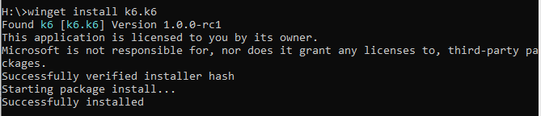

## Basic Structure of a k6 Test

For k6 to be able to interpret and execute our test, every k6 script follows a common structure, revolving around a few core components:

1. Default function: This is where the test logic resides. It defines what our test will do and how it will behave during execution. It should be exported as the default function in our script.
2. Imports: We can import additional k6 modules or JavaScript libraries (jslibs) to extend our script’s functionality, such as making HTTP requests or simulating browser interactions. *(P.S.: k6 is not built upon Node.js, and instead uses its own JavaScript runtime. Compatibility with some npm modules may vary.)*
3. Options (optional): Enable us to configure the execution of the test, such as defining the number of virtual users, the test duration, or setting performance thresholds.
4. Lifecycle operations (optional): Because our test might need to run code before and/or after the execution of the test logic, such as parsing data from a file, or download an object from Amazon S3, lifecycle operations allow us to write code, either as predefined functions or within specific code scopes, that will be executed at different stages of the test execution.

## Testing

### 1 Virtual user running for 5 minutes

Code:

import http from 'k6/http';

import { sleep } from 'k6';

export default function () {

const res = http.get('https://groupiig.techarttrekkies.com.np/');

console.log('Status code: ${res.status}');

sleep(1);

}

Output:

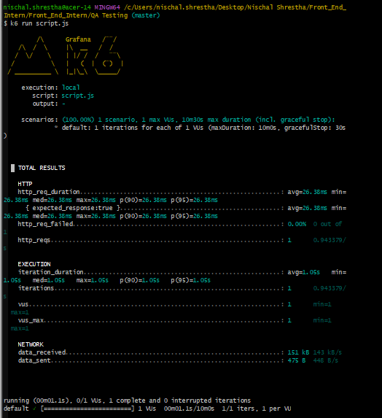

Result:

* The duration of the HTTP requests:

| **Metrics** | **Duration** | **Expected Response** |
| --- | --- | --- |
| Average | 26.38ms | 26.38ms |
| Minimum | 26.38ms | 26.38ms |
| Median | 26.38ms | 26.38ms |
| Maximum | 26.38ms | 26.38ms |
| p(90) | 26.38ms | 26.38ms |
| p(95) | 26.38ms | 26.38ms |

* 0.00% out of 1 HTTP request failed
* 1 HTTP request was made at a rate of 0.943379 req/second
* Iteration duration:
  + Average: 1.05s
  + Minimum: 1.05s
  + Median: 1.05s
  + Maximum: 1.05s
  + p(90): 1.05s
  + p(95): 1.05s
* Iterations: 1 iteration performed at a rate of 0.943379 iterations/second
* Virtual users: 1
* Maximum Virtual users: 1
* Data received: 151 kB, Average rate: 143 kB/s
* Data sent: 475 B, Average rate: 448 B/s
* Running: 1.1 s
* 0 out of 1 virtual user was active
* 1 iteration was successfully completed and 0 were interrupted

### 10 get HTTP requests to a Techart URL & wait for 1 second between requests

Code:

//Import http module to make HTTP requests

import http from 'k6/http';

//Import sleep function to introduce delays

import { sleep } from 'k6';

export const options = {

//Define the number of iterations for the test

iterations: 10,

}

// The default exported function is gonna be picked up by k6 as the entry point for the test script. It will be executed repeatedly in "iterations" for the whole duration of the test.

export default function() {

//make a get request to the target URL

http.get('https://groupiig.techarttrekkies.com.np/');

//Sleep for 1 second to simulate real-world usage

sleep(1);

}

Output:

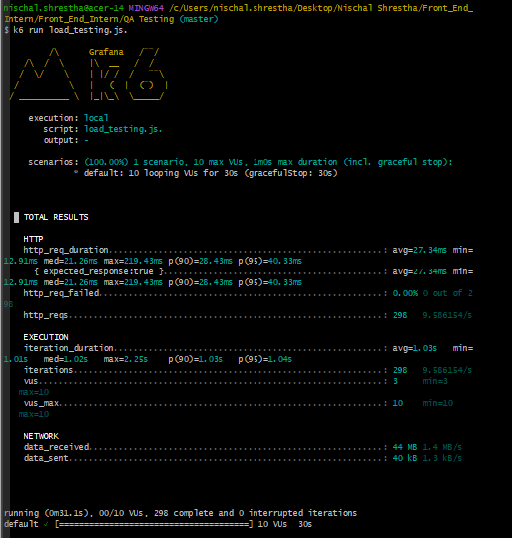

Result:

* The duration of the HTTP requests:

| **Metrics** | **Duration** | **Expected Response** |
| --- | --- | --- |
| Average | 27.34ms | 27.34ms |
| Minimum | 12.91ms | 12.91ms |
| Median | 21.26ms | 21.26ms |
| Maximum | 219.43ms | 219.43ms |
| p(90) | 28.43ms | 28.43ms |
| p(95) | 40.33ms | 40.33ms |

* 0.00% out of 2 HTTP request failed
* 298 HTTP request was made at a rate of 9.586154 req/second
* Iteration duration:
  + Average: 1.03s
  + Minimum: 1.01s
  + Median: 1.02s
  + Maximum: 1.25s
  + p(90): 1.03s
  + p(95): 1.04s
* Iterations: 298 iteration performed at a rate of 9.586154 iterations/second
* Virtual users:
  + Minimum: 3
  + Maximum: 10
* Data received: 44 MB, Average rate: 1.4 MB/s
* Data sent: 40 kB, Average rate: 1.3 kB/s
* Running: 31.1s
* 0 out of 10 virtual user was active
* 298 iterations were successfully completed and 0 were interrupted

### Load Testing (200 Virtual Users for 30m 30s)

Code:

import http from 'k6/http';

import { sleep } from 'k6';

export const options = {

stages: [

{ duration: '5m', target: 200 }, //ramp up

{ duration: '20m', target: 200 }, //stable

{ duration: '5m', target: 0 }, //ramp down to 0 user

]

};

export default function () {

http.get('https://groupiig.techarttrekkies.com.np/');

sleep(1);

}

Output:

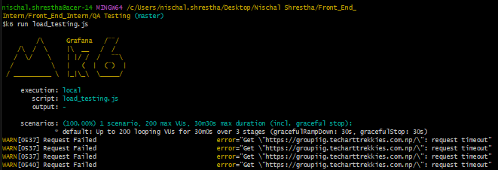

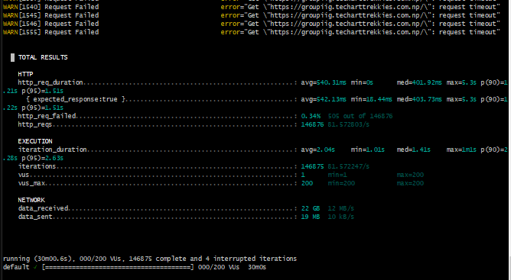

Result:

* The duration of the HTTP requests:

| **Metrics** | **Duration** | **Expected Response** |
| --- | --- | --- |
| Average | 540.31ms | 542.13ms |
| Minimum | 3s | 16.44ms |
| Median | 501.92ms | 403.73ms |
| Maximum | 5.3s | 5.3s |
| p(90) | 1.51s | 1.51s |
| p(95) | 1.51s | 1.51s |

* 0.34% totalling 505 failed out of 146,878 HTTP request failed
* 146,878 HTTP requests were made at an average rate of 81.57 req/second
* Iteration duration:
  + Average: 2.04s
  + Minimum: 1.01s
  + Median: 1.41s
  + Maximum: 1.5s
  + p(90): 2.63s
  + p(95): 2.63s
* Iterations: 146,875 iteration performed at a rate of 81.57 iterations/second
* Virtual users:
  + Minimum: 1
  + Maximum: 200
* Data received: 22 GB, Average rate: 12 MB/s
* Data sent: 19 MB, Average rate: 10 kB/s
* Running: 30m 0s
* All 200 virtual users had finished their execution
* 146,875 iterations were successfully completed and 4 were interrupted

### Stress Testing

#### Up to 1000 users

Code:

import http from 'k6/http';

import { sleep } from 'k6';

export const options = {

stages: [

{ duration: '1m', target: 200 }, //ramp up

{ duration: '5m', target: 200 }, //stable

{ duration: '1m', target: 800 }, //ramp up

{ duration: '5m', target: 200 }, //stable

{ duration: '1m', target: 1000 }, //ramp up

{ duration: '5m', target: 1000 }, //stable

{ duration: '5m', target: 0 }, //ramp down to 0 users

]

};

export default function () {

http.get('https://groupiig.techarttrekkies.com.np/');

sleep(1);

}

Output:

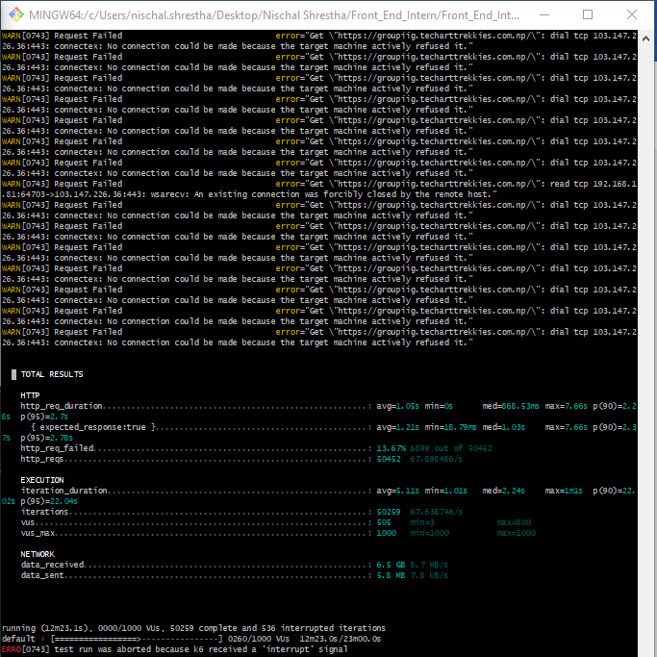

Result:

* The duration of the HTTP requests:

| **Metrics** | **Duration** | **Expected Response** |
| --- | --- | --- |
| Average | 1.06s | 1.21s |
| Minimum | 0s | 11ms |
| Median | 68.53ms | 0s |
| Maximum | 7.66s | 7.66s |
| p(90) | 2.7s | 2.7ms |
| p(95) | 2.7s | 2.7ms |

* 99.99% totaling 50,250 out of 50,256 HTTP request failed
* 50,256 HTTP request was made at a rate of 67.8 req/second
* Iteration duration:
  + Average: 1.01s
  + Minimum: 11ms
  + Median: 24s
  + Maximum: 1m 1s
  + p(90): 2.2s
  + p(95): 2.2s
* Iterations: 50,250 iteration performed at a rate of 67.8 iterations/second
* Virtual users:
  + Minimum: 1
  + Maximum: 1000
* Data received: 6.5 GB, Average rate: 8.7 MB/s
* Data sent: 6.8 MB, Average rate: 9.1 kB/s
* Running: 12m 23.1s
* All 1000 virtual users had finished
* 50,250 iterations were completed (though likely with failures) and 536 were interrupted

#### Up to 200 users

Code:

import http from 'k6/http';

import { sleep } from 'k6';

export const options = {

stages: [

{ duration: '1m', target: 50},

{ duration: '5m', target: 50},

{ duration: '1m', target: 100},

{ duration: '5m', target: 100},

{ duration: '1m', target: 150},

{ duration: '5m', target: 150},

{ duration: '1m', target: 200},

{ duration: '5m', target: 200},

]

};

export default function () {

http.get('https://groupiig.techarttrekkies.com.np/');

sleep (1);

}

Output:

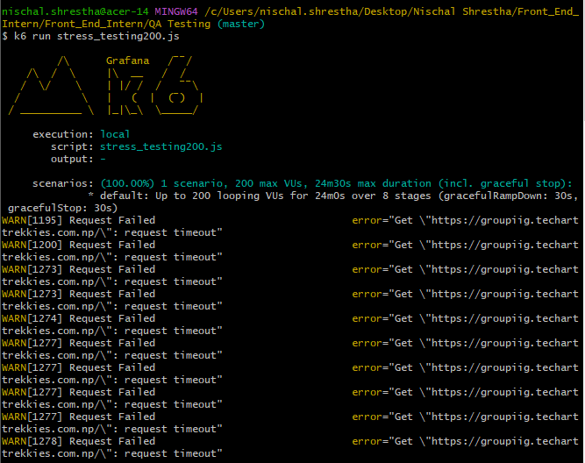

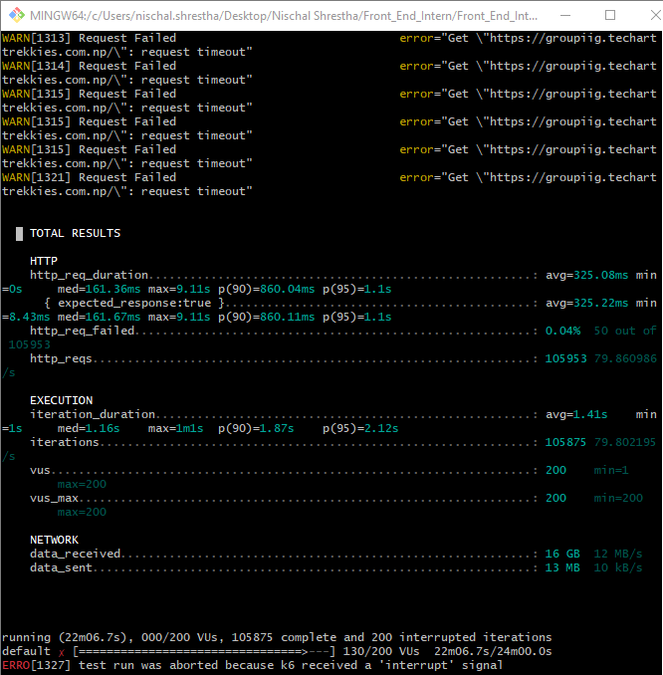

Result:

* The duration of the HTTP requests:

| **Metrics** | **Duration** | **Expected Response** |
| --- | --- | --- |
| Average | 325.08ms | 325.22ms |
| Minimum | 0s | 8.43ms |
| Median | 161.36ms | 161.67ms |
| Maximum | 9.11s | 9.11s |
| p(90) | 860.04ms | 860.11ms |
| p(95) | 1.1s | 1.1s |

* 0.04% totaling 50 out of 1,05,953 HTTP request failed
* 1,05,875 HTTP request was made at a rate of 79.860 req/second
* Iteration duration:
  + Average: 1.41s
  + Minimum: 1s
  + Median: 1.16s
  + Maximum: 1m 1s
  + p(90): 1.87s
  + p(95): 2.12s
* Iterations: 1,05,875 iteration performed at a rate of 79.80 iterations/second
* Virtual users:
  + Minimum: 1
  + Maximum: 200
* Data received: 16 GB, Average rate: 12 MB/s
* Data sent: 13 MB, Average rate: 10 kB/s
* Running: 22m 06.7s
* 130 virtual users had finished
* 1,05,875 iterations were completed and 200 were interrupted

### Spike Testing (300 Virtual Users for 7m)

Code:

import http from 'k6/http';

import { sleep } from 'k6';

export const options = {

stages: [

{ duration: '1m', target: 300},

{ duration: '5m', target: 300},

{ duration: '1m', target: 0},

]

};

export default function () {

http.get('https://groupiig.techarttrekkies.com.np/');

sleep (1);

}

Output:

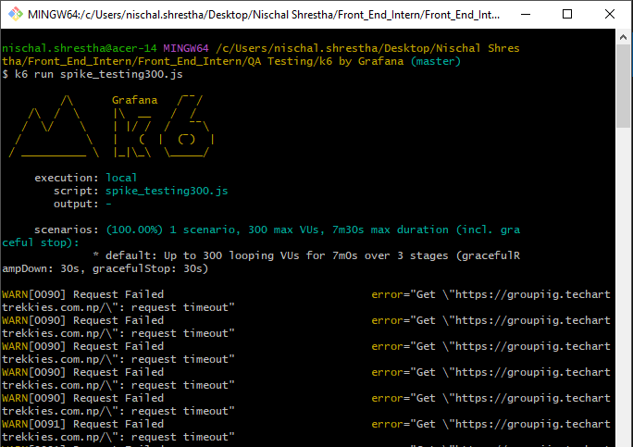

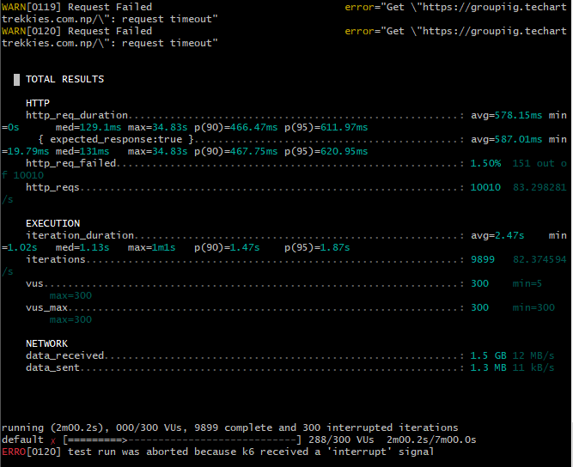

Result:

* The duration of the HTTP requests:

| **Metrics** | **Duration** | **Expected Response** |
| --- | --- | --- |
| Average | 578.15ms | 587.01ms |
| Minimum | 0s | 19.79ms |
| Median | 129.1ms | 131ms |
| Maximum | 34.83s | 34.83s |
| p(90) | 466.47ms | 467.75ms |
| p(95) | 611.97ms | 620.95ms |

* 1.50% totalling 151 failed out of 10,010 HTTP request failed
* 10,010 HTTP requests were made at an average rate of 83.2982 req/second
* Iteration duration:
  + Average: 2.47s
  + Minimum: 1.02s
  + Median: 1.13s
  + Maximum: 1m 1s
  + p(90): 1.47s
  + p(95): 1.87s
* Iterations: 9,899 iteration performed at a rate of 82.374 iterations/second
* Virtual users:
  + Minimum: 5
  + Maximum: 300
* Data received: 1.5 GB, Average rate: 12 MB/s
* Data sent: 1.3 MB, Average rate: 11 kB/s
* Running: 2m 0.2s
* 288 virtual users had finished their execution
* 9,899 iterations were completed and 300 were interrupted

### Soak Testing (50 Virtual Users for 40m)

Code:

import http from 'k6/http';

import { sleep } from 'k6';

export const options = {

stages: [

{ duration: '5m', target: 50},

{ duration: '30m', target: 50},

{ duration: '5m', target: 0},

]

};

export default function () {

http.get('https://groupiig.techarttrekkies.com.np/');

sleep (1);

}

Output:

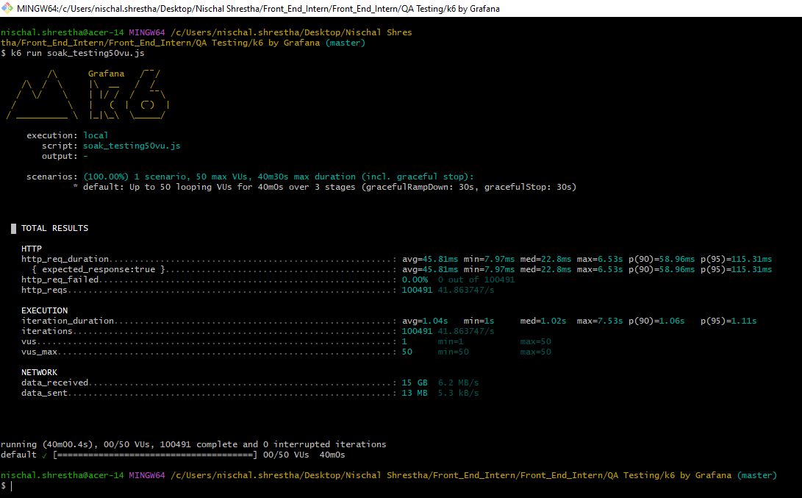

Result:

* The duration of the HTTP requests:

| **Metrics** | **Duration** | **Expected Response** |
| --- | --- | --- |
| Average | 45.81ms | 45.81ms |
| Minimum | 7.97s | 7.97ms |
| Median | 22.8ms | 22.8ms |
| Maximum | 6.53s | 6.53s |
| p(90) | 58.96ms | 58.96ms |
| p(95) | 115.31ms | 115.31ms |

* 0.00% totalling 0 failed out of 1,00,491 HTTP request failed
* 1,00,491 HTTP requests were made at an average rate of 41.86 req/second
* Iteration duration:
  + Average: 1.04s
  + Minimum: 1s
  + Median: 1.02s
  + Maximum: 7.53s
  + p(90): 1.06s
  + p(95): 1.11s
* Iterations: 1,00,491 iteration performed at a rate of 41.86 iterations/second
* Virtual users:
  + Minimum: 1
  + Maximum: 50
* Data received: 15 GB, Average rate: 6.2 MB/s
* Data sent: 13 MB, Average rate: 5.3 kB/s
* Running: 40m 0.4s
* 50 virtual users had finished their execution
* 1,00,491 iterations were completed and 0 were interrupted

# CONCLUSION

The Load Testing results indicate that “<https://groupiig.techarttrekkies.com.np/>” demonstrates reasonable performance and stability under moderate and sustained loads (up to 200 virtual users). However, the application exhibits significant performance degradation and high failure rates when subjected to higher concurrent users (especially 1000) and sudden traffic spikes which need significant optimizations. Addressing the identified bottlenecks and implementing strategies to handle peak loads will be critical for ensuring a consistent and positive user experience.